SCC x MAIA Proposal [SIGNED]
Client: SCC Holdings - Adam Cher
Date: 4/2/2026

1. Executive Summary
SCC runs several high-value, high-frequency workflows that depend on fast coordination between sales, finance, operations, and service teams.
Today, many of these workflows still rely on manual WhatsApp messages, calls, follow-ups, and re-keying into internal systems. This creates avoidable delays, miscommunication, pricing mistakes, missed follow-ups, and unnecessary admin load.
MAIA helps SCC solve this by acting as a WhatsApp-first operational layer that sits on top of your current system. It helps your staff move faster, follow the right SOP, and reduce exceptions—without forcing a risky ERP replacement.
For SCC, the most immediate impact areas are:
- Food service machine sales and spare parts orders
- Service and maintenance quotation turnaround
- Finance visibility and invoice knock-off
- Repeat order processing
- Management visibility across sales and field activity
The goal is simple:
Help SCC process orders faster, quote faster, follow up better, and reduce admin mistakes—using a workflow your team will actually adopt.

2. SCC’s Current Operational Challenges
SCC Holdings is running multiple operational workflows that are high-frequency, coordination-heavy, and depend on information flowing correctly between sales, finance, and maintenance.

A) B2B sales order processing is still manual-heavy
When orders come in through WhatsApp, calls, or ad-hoc messages, teams usually face:
- Manual re-keying of customer details + items into ERP/accounting system
- Wrong SKU / wrong quantity / missing delivery details
- Time lost clarifying info back-and-forth with customers and internally
- Sales team spends time “admin-ing” instead of selling

B) Finance visibility and invoice knock-off is fragmented
Finance needs faster, structured ways to:
- Get daily sales reporting without compiling manually
- Process Statement of Account (SOA) and correctly map payments/amounts to invoices
- Tag invoices (attribution) so reporting and follow-up becomes cleaner

C) Outdoor sales updates are not captured consistently
Sales leaders want visibility into:
- Who salespeople met, what was discussed, next steps
- Daily updates are hard to enforce (especially when updates are voice notes / informal)
- Teams can’t easily retrieve “what happened last meeting?” without scrolling chats or asking around
- Sales team don't have a simpler way to update the meeting information after they have met a client

D) Maintenance work needs faster quoting + better workforce visibility
Maintenance teams need tools to:
- Generate quotations quickly while on-site (during diagnosis)
- Give management visibility on where field staff are (location + activity context)

2. What you will get after implementing MAIA

A) A B2B AI “Sales Support” workflow that creates Quotations and Sales Orders for your team
SCC staff will be able to use MAIA via WhatsApp to:
- create quotations from chat with natural chat: “Create order for Customer A, Item X 10 cartons, deliver Friday”
- convert quotations into sales orders with natural chat: “Create order for Customer A, Item X 10 cartons, deliver Friday”
- validate missing details before submission (address, date, PIC, delivery method, etc.)
- check pricing, stock, and customer-specific rules (if enabled)
- retrieve order status without logging into ERP
- Integrated to ERP
This is especially useful for:
- food service machine sales
- spare parts orders
- repeat dealer/customer orders
- animal feed orders coming in through chat or calls
Business outcome:
Faster order turnaround, fewer order-entry mistakes, and less dependency on manual admin.

B) Finance Workflow and Chatbot for Daily Reporting and Invoice Knock-Off
Finance team can use MAIA (WhatsApp-based) to:
- Receive daily sales report automatically (scheduled)
- Submit a Statement of Account (SOA) and have MAIA:
- Extract invoice numbers + amounts to knock off
- Produce a “knock-off suggestion list” for finance confirmation
- Record attribution tags per invoice (e.g., “Watsons”, “MR DIY”, “Promo-2026Q1”, “Key Account”, “Channel: HORECA”, etc.)
Business outcome:
Faster reconciliation, cleaner reporting, and less manual compilation.

C) Outdoor Sales “Meeting Logger” inside the sales agent chatbot
Outdoor sales can:
- Record who they met + meeting notes (text / voice input)
- Send voice notes to MAIA summarizing meetings and updates
- Management can query anytime:
- “Show me last meeting notes for Customer ABC”
- “What did Ali update yesterday?”
- “List all meetings logged this week by team”
- Meeting notes will also be updated on SAP

D) A Maintenance chatbot for on-site quotation + management visibility
Maintenance team can:
- Generate a quotation while on-site after diagnosis
- Capture site details, issue category, parts/labour, photos (optional), and quotation output
Management can:
- See where maintenance staff are (location visibility, subject to privacy/consent + implementation approach)

3. How MAIA works

Scenario A — Sales team creates a B2B order
- Sales receives order (WhatsApp/email/call notes).
- Sales forwards PO to MAIA (WhatsApp/email)
- MAIA confirms:
- SKU matching (avoid wrong variants)
- Missing details (address/date/PIC/contact)
- Optional guardrails (credit/stock/price rules if enabled)
- MAIA generates the Sales Order output and records it into the backend system.
- MAIA notifies the next PIC (warehouse/ops/finance) if you want internal task handoffs.
✅ Outcome: faster processing, fewer mistakes, consistent SOP.

Scenario B — Finance runs daily sales + invoice knock-off flow
- MAIA sends daily sales report to finance WhatsApp (scheduled).
- Finance submits SOA (PDF/image/Excel) via WhatsApp.
- MAIA extracts invoice list + amounts and proposes “knock-off mapping” for confirmation.
- Finance tags invoices (channel/customer/category) during confirmation.
- MAIA outputs a structured summary report (and exports if required).
✅ Outcome: less manual compilation + cleaner reconciliation trail.

Scenario C — Outdoor sales records meeting notes + retrieves history
- Salesperson messages or voice-notes MAIA at end of day.
- MAIA prompts for structured fields (optional): customer, contact, purpose, outcome, next step, follow-up date.
- MAIA stores notes under that account.
- Anyone with permission can query later: “What happened last meeting?”
✅ Outcome: management visibility + no lost field intel.

Scenario D — Maintenance generates quotation on-site
- Staff opens MAIA and selects “Create maintenance quotation”.
- MAIA collects: site, issue category, parts/labour, remarks, photos (optional).
- MAIA generates quotation PDF and sends to staff (and optionally to customer contact).
- Management dashboard shows activity + (optional) location snapshot.
✅ Outcome: faster quoting + better operational control.

4. Recommended delivery scope

Phase 1 — Core: B2B Sales Agent chatbot + backend integration
Includes:
- Internal-facing Sales Agent bot
- Sales order workflow aligned to SCC’s SOP
- User roles + permissions
- Integration approach agreed (ERP/accounting + master data sync)
- Basic outputs (SO/quotation/invoice outputs depending on your flow)
- Training + go-live support

Phase 2 — Finance chatbot module (daily report + SOA knock-off + invoice tagging)
Includes:
- Daily scheduled sales report via WhatsApp
- SOA submission and extraction (invoice + amount)
- Knock-off confirmation flow
- Invoice tagging + exportable summaries
- Audit trail of who confirmed/edited

Phase 3 — Outdoor sales meeting logger module (text + voice note)
Includes:
- Meeting capture flow (structured + free-text)
- Voice note ingestion for daily updates
- Query interface (“last meeting notes”, “weekly summaries”, etc.)
- Optional reminders: “submit daily update by 7pm”

Phase 4 — Maintenance chatbot module (quotation + location visibility)
Includes:
- On-site quotation generation flow
- Quotation PDF output
- Internal tracking dashboard for quotations created
- Location visibility approach (to be confirmed: device sharing / app check-in / WhatsApp live location policy)

5. Setting up (after proposal confirmation)
- Kickoff workshop (requirements gathering)
- Confirm SOP flows for Sales / Finance / Outdoor updates / Maintenance quoting
- Confirm which outputs are required (SO/INV/quotation templates)
- System onboarding + integration setup
- Connect MAIA to SCC’s system(s)
- Sync key masters: customers, items/SKUs, pricing rules, invoice list (as needed)
- Chat flow configuration + permissions
- Define user roles (sales, finance, management, maintenance)
- Lock down access (who can see what data)
- Testing (UAT)
- Test each scenario with sample orders/SOA/meeting notes/maintenance cases
- Confirm edge cases and escalation rules
- Training + go-live + hypercare
- Train each department
- Support period to ensure adoption + SOP compliance

6. What we provide vs what you need

MAIA provides
✅ Sales agent chatbot (B2B)
✅ Finance chatbot workflows (daily report + SOA + tagging)
✅ Outdoor sales meeting capture (text + voice notes)
✅ Maintenance quotation chatbot + management visibility layer
✅ Backend dashboard + audit trail
✅ Training + rollout support

SCC needs to provide
✅ Current SOPs / decision rules (sales, finance, maintenance)
✅ Sample documents (sanitized):
- Sales order / invoice formats
- SOA samples
- Maintenance quotation format (if any)
✅ User list + role mapping
✅ System access path for integration (ERP/accounting + invoice list + customer/SKU master source)
✅ Location visibility policy for maintenance staff (what’s acceptable + consent boundaries)

7. Timeline
Phase | Scope | Estimated Timeline
Phase 1 | Core: B2B Sales Agent chatbot + backend integration  Includes:  - Internal-facing Sales Agent bot  - Sales order workflow aligned to SCC’s SOP  - User roles + permissions  - Integration approach agreed (ERP/accounting + master data sync)  - Basic outputs (SO/quotation/invoice outputs depending on your flow)  - Training + go-live support | 3 Weeks
Phase 2 | Finance chatbot module  Includes:  - Daily scheduled sales report via WhatsApp  - SOA submission and extraction (invoice + amount)  - Knock-off confirmation flow  - Invoice tagging + exportable summaries  - Audit trail of who confirmed/edited | 2 Weeks
Phase 3 | Outdoor sales meeting logger module  Includes:  - Meeting capture flow (structured + free-text)  - Voice note ingestion for daily updates  - Query interface (“last meeting notes”, “weekly summaries”, etc.)  - Optional reminders: “submit daily update by 7pm” | 1 week
Phase 4 | Maintenance chatbot module  Includes:  - On-site quotation generation flow  - Quotation PDF output  - Internal tracking dashboard for quotations created  - Location visibility approach (to be confirmed: device sharing / app check-in / WhatsApp live location policy) | 2 Weeks

The delivery dates above are indicative and may change depending on external factors, such as the availability of required information (e.g., SAP integration methods, data formats, access credentials), timely client feedback, and other dependencies outside MAIA’s control. Any timeline adjustments will be communicated accordingly.

8. Commercials (Implementation + Subscription)

A) One-time upfront cost
Category | Component / Module | What it covers | One-time fee (RM)
B2B MAIA (Phase 1) | Internal WhatsApp Order Assistant (B2B) | Turns WhatsApp/PO/voice/image orders into a ready-to-confirm sales order; staff confirms before submission | RM48,000  RM 20,000
B2B MAIA (Phase 1) | Pricing & customer rules | Checks customer-specific pricing to prevent wrong-price disputes | RM48,000  RM 20,000
B2B MAIA (Phase 1) | Stock availability check | Prevents “confirmed order but no stock” | RM48,000  RM 20,000
B2B MAIA (Phase 1) | Payment slip capture | Extracts amount/date; marks paid with approval trail | RM48,000  RM 20,000
B2B MAIA (Phase 1) | Ops tasking (warehouse/packing/delivery) | Sends pick/pack instructions + task list | RM48,000  RM 20,000
B2B MAIA (Phase 1) | Management order overview | One view of order status for owners | RM48,000  RM 20,000
B2B MAIA (Phase 1) | Role-based access | Sales vs warehouse vs driver vs management access | RM48,000  RM 20,000
Customized Modules  (Phase 2 onwards) | Finance Chatbot Module | - Daily scheduled sales report via WhatsApp  - SOA submission and extraction (invoice + amount)  - Knock-off confirmation flow  - Invoice tagging + exportable summaries  - Audit trail of who confirmed/edited | RM 22,500  RM 20,000
Customized Modules  (Phase 2 onwards) | Outdoor Sales Meeting Logger Chatbot Module | - Meeting capture flow (structured + free-text)  - Voice note ingestion for daily updates  - Query interface (“last meeting notes”, “weekly summaries”, etc.)  - Reminders: “submit daily update by 7pm” | RM 7,500
Optional Module | Maintenance chatbot module | - On-site quotation generation flow  - Quotation PDF output  - Location visibility approach (to be confirmed: user input / device sharing / app check-in / WhatsApp live location policy) | RM 22,500  RM 20,000
Total |  |  | RM 47,500 (excluding optional module)

Payment Terms (excluding optional module)
Milestone | Percentage | Amount (RM) | Payment Trigger
Upfront Payment | 30% | RM 14,250 | Upon project commencement
Completion of Phase 2 | 35% | RM 16,625 | Upon completion of Finance Chatbot Module
Completion of Phase 3 | 35% | RM 16,625 | Upon completion of Outdoor sales meeting logger module

B) Monthly subscription tiers (by order volume)
Tier | Orders/month cap | Monthly fee (RM)
T1 | No limit  Up to 500 | 2,500

Subscription excludes cloud hosting, GPT cost estimated at under RM1,000 per month.

9. Acknowledgement & Agreement
This document serves as a baseline specification and framework for MAIA's implementation and usage. By signing below, both parties agree to the commitments, responsibilities, and exclusions set out herein.
For Mindhive: | For SCC:

  ____________________________
  Signature
  Name:
  Position:
  Date:
  ____________________________
  Signature
  Name:
  Position:
  Date:

Appendix
1) B2B - Internal Facing Chatbot (For Internal Sales Agents)
Scenario: Sales/parts team queries available items for a specific car model, then checks if the same items can be used for another model.
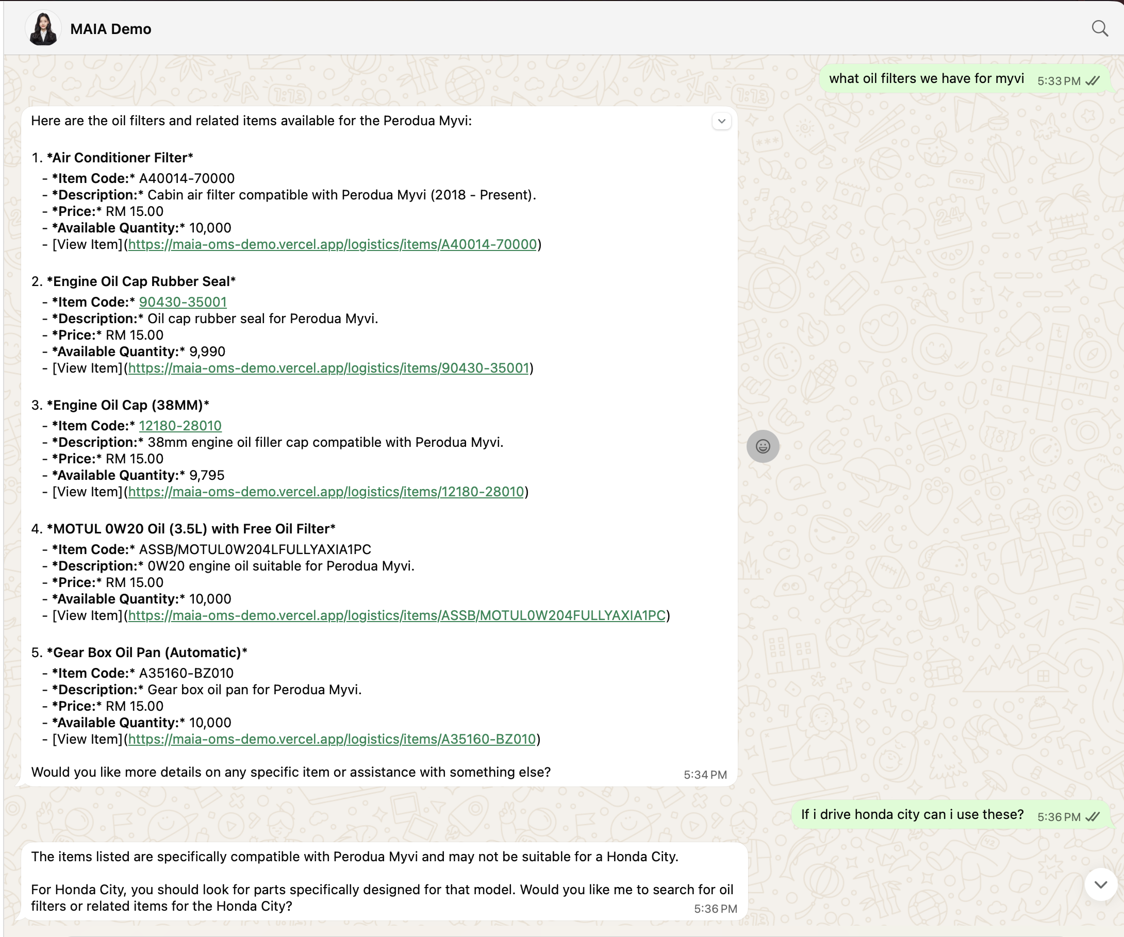
Flow
- The user asks MAIA in WhatsApp: “what oil filters we have for myvi”
- MAIA searches the Item Database and returns a structured list of matching items, including:
- Item name + description (fitment notes)
- Item code (SKU)
- Price
- Available quantity
- Clickable “View Item” link to the item page
- The user asks a follow-up compatibility question: “If i drive honda city can i use these?”
- MAIA flags that the results were specific to Perodua Myvi and may not be compatible with Honda City.
- MAIA prompts the user to search specifically for Honda City items.
Benefits
- Instant catalog visibility (no manual searching): Staff can find items, price, and stock instantly from WhatsApp.
- Reduces wrong-part mistakes: Fitment/compatibility guardrails prevent selling the wrong parts for the wrong model.
- Faster customer response time: Sales can answer “do you have stock?” + “what’s the code/price?” in one reply.
- Fewer back-and-forth clarifications: Structured output reduces follow-up questions and confusion.

2) B2B - Internal Facing Chatbot (For Internal Sales Agents)
Scenario: Creating Sales Order
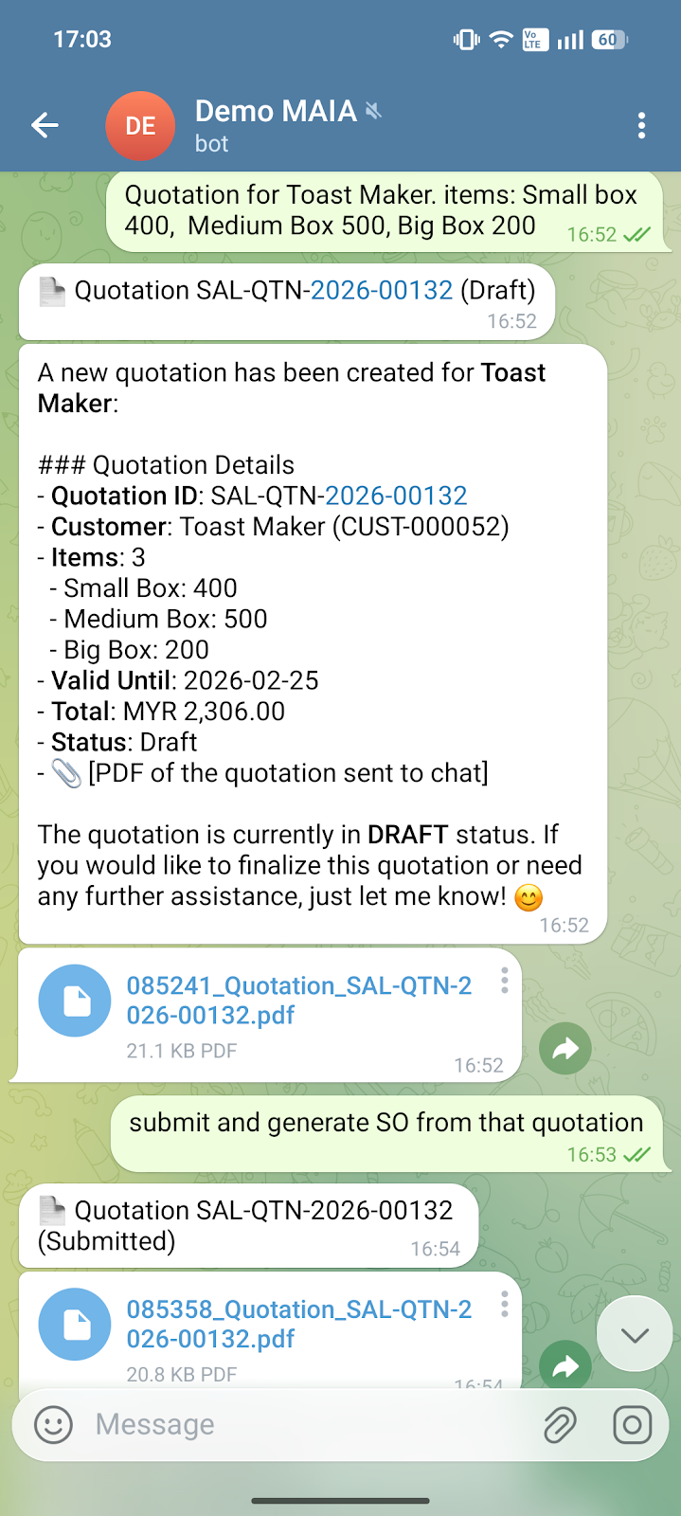 | 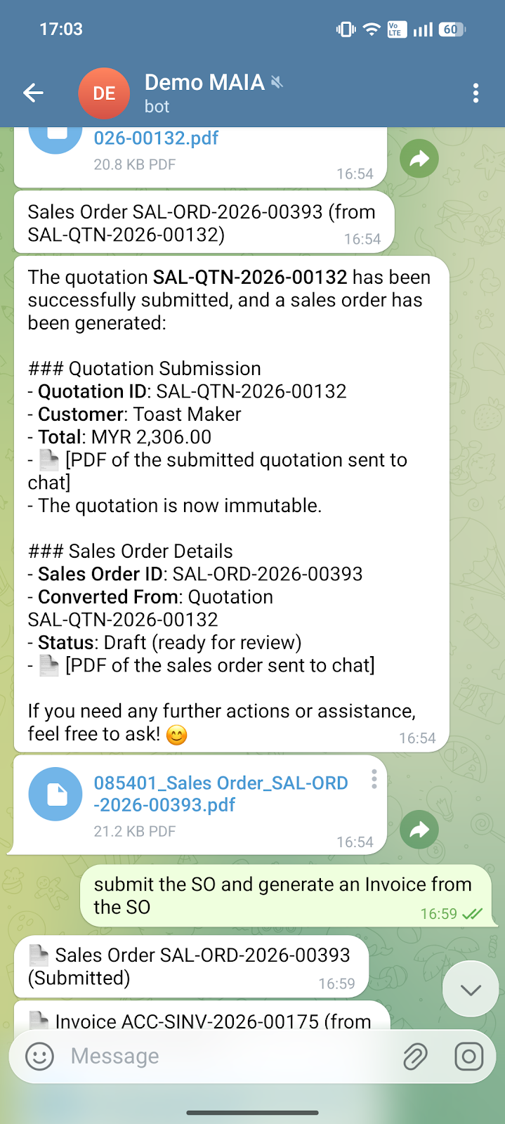 | 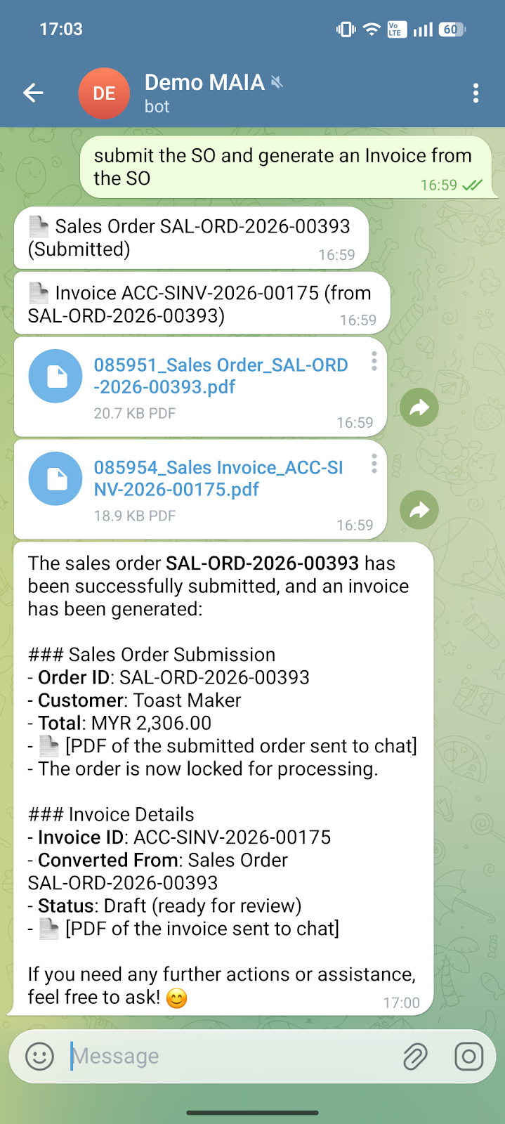
Flow
- Creates a Quotation (Draft)
- MAIA generates a quotation for the customer (items + quantities + total).
- It then shares the quotation PDF in chat so the user/customer can review.
- Submits the quotation and auto-creates a Sales Order
- When the user says “submit and generate SO”, MAIA finalizes the quotation (so it becomes “official”).
- MAIA converts it into a Sales Order and shares the Sales Order PDF.
- Submits the Sales Order and auto-creates an Invoice
- When the user says “submit SO and generate invoice”, MAIA submits the Sales Order.
- MAIA creates the Invoice and shares the Invoice PDF.
- The flow is now “locked” for processing (less chance of people accidentally editing numbers).
Benefits
- Faster order processing (no admin bottleneck)
- Sales/admin doesn’t need to retype into ERP.
- A quote and order can be created in minutes from chat — especially useful when orders come in nonstop.
- Fewer mistakes + less back-and-forth
- Reduces common errors like wrong SKU/qty/price, missing items, or forgetting to invoice.
- MAIA follows a consistent sequence, so fewer steps get skipped.
- Clean paperwork instantly (professional + consistent)
- Every step produces the right PDF document automatically (Quotation / Sales Order / invoice).
- Easy to forward to customers, finance, warehouse, or drivers — no “wait I resend the latest version”.
- Better accountability and traceability
- Every document has a status (Draft/Submitted) and a clear trail of what was generated from what.
- This makes it easier to audit issues later (who created it, when, what changed).
- Helps owners scale without hiring more “paperwork people”
- As volume grows, the biggest pain is usually admin workload + human error.
- MAIA reduces the dependence on a single clerk/sales admin to keep operations moving.

3) B2B - Internal Facing Chatbot (For Internal Sales Agents)
Scenario: Data Querying For Orders
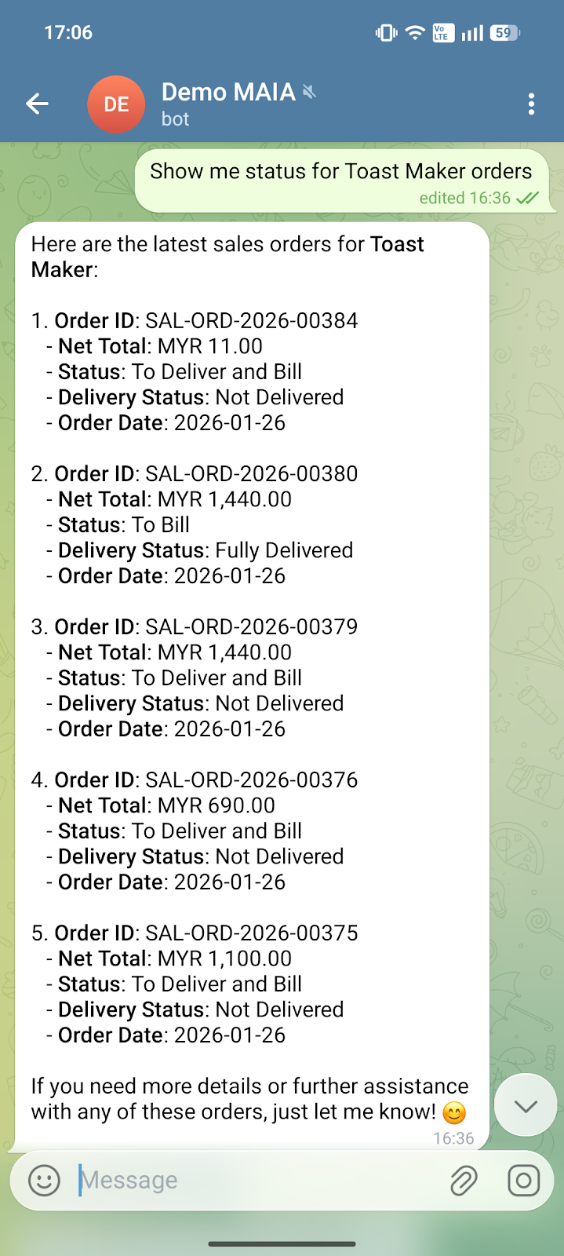
Flow
- The user asks: “Show me status for Toast Maker orders”
- MAIA then:
- Searches the ERP for the latest Sales Orders under that customer (Toast Maker)
- Pulls key fields for each order:
- Order ID
- Net Total (amount)
- Billing status (e.g., To Bill)
- Delivery status (e.g., Fully Delivered / Not Delivered)
- Order date
- Formats it into a clean summary inside WhatsApp, so the user doesn’t need to open ERP and click around.
Benefits
- Instant visibility without logging into ERP
- Sales, ops, and even owners can check “what’s happening” in seconds — directly in WhatsApp.
- Faster customer replies = better customer experience
- When customers ask:
- “Where’s my order?”
- “Have you delivered?”
- “Why haven’t I received the invoice?”
- Reduces internal back-and-forth
- Instead of ops asking warehouse, warehouse asking admin, admin checking ERP, MAIA gives a single source of truth immediately.
- Better collections and fewer missed invoices
- Seeing orders stuck at “To Bill” makes it easier for finance/admin to follow up and bill faster.
- Helps managers spot problems early
- A quick scan shows:
- Multiple orders Not Delivered → delivery backlog
- Many orders To Bill → invoicing bottleneck

4) B2B - Internal Facing Chatbot (For Internal Sales Agents)
Scenario: Data Querying For Dynamic Pricings
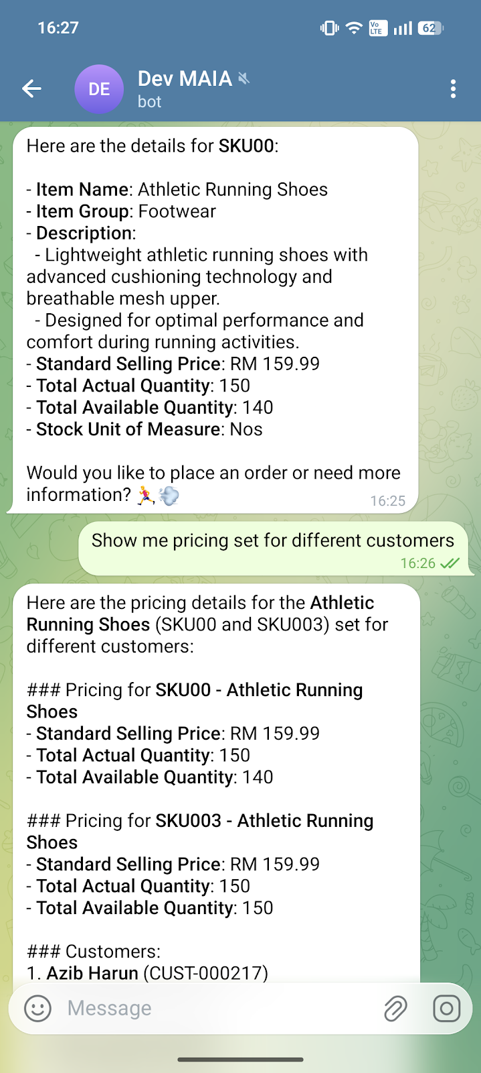
- The user asks: “Show me pricing set for different customers”
- MAIA answers “pricing set for different customers”
MAIA responds by pulling pricing configurations / customer price lists for the same items (e.g., SKU00, SKU003) and listing:
- Standard selling price (and in a fuller version, this is where customer-specific prices/tiers/discounts would show)
- Relevant inventory snapshot
- Which customers have specific pricing tied to them (it starts listing customers like “Azib Harun …”)
In short: MAIA is checking “what price should we sell this SKU to this customer?” based on your pricing information.

Benefits
- Faster quoting and order taking
- Sales can confirm price + stock immediately while chatting — less “I check first and get back to you”.
- Fewer wrong-price mistakes (big one)
- Customer-specific pricing is where humans often mess up (old price lists, wrong tier, wrong customer). MAIA reduces disputes, credit notes, and awkward “sorry wrong price” situations.
- Better stock confidence
- Seeing available quantity helps sales avoid overselling and prevents ops chaos later.
- Less dependency on one “ERP expert”
- Many SMEs have only 1–2 people who know how to find item master, price lists, and stock views. MAIA spreads that capability to the whole team via WhatsApp.
- Owner-level control and consistency
- Pricing discipline improves — everyone references the same system rules, not “last time we sold at RMxxx”.

5) B2B - Internal Facing Chatbot (For Internal Sales Agents)
Scenario: Data Querying for Customer Information
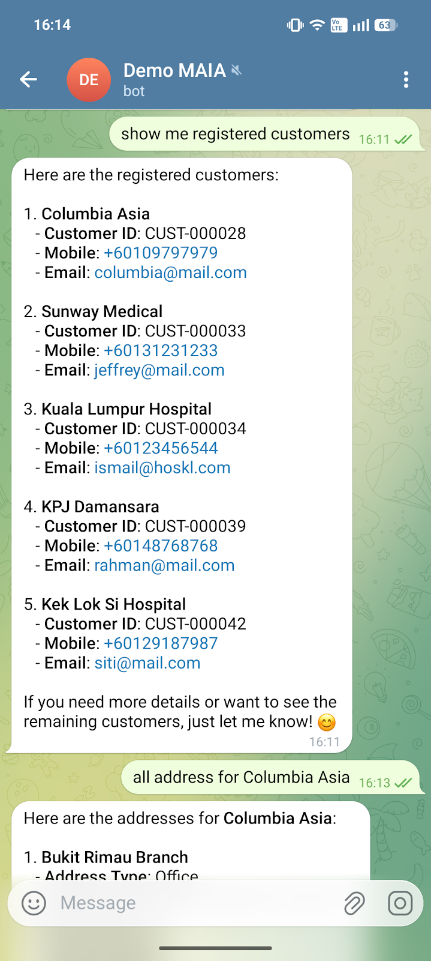 | 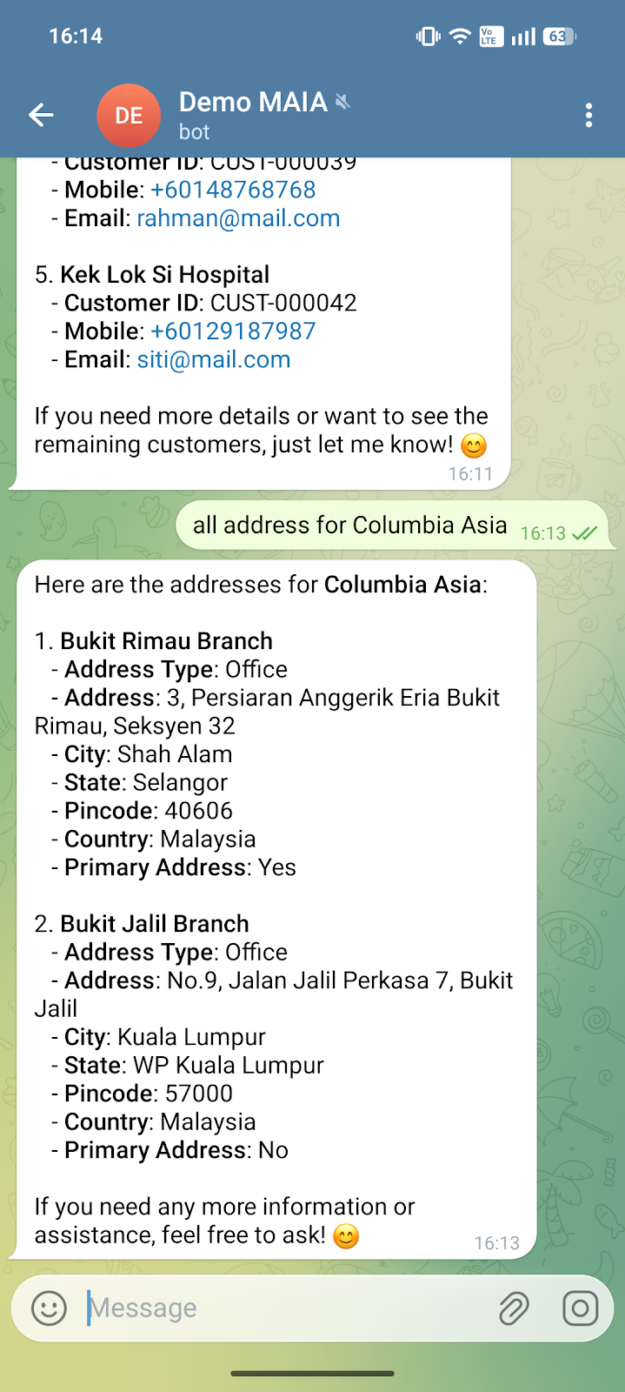
- User asks: “show me registered customers”
- MAIA replies with a clean list that includes:
- Customer name
- Customer ID
- Mobile / Email (where available)
- Pulls the customer’s saved addresses/branches
- User then asks: “call address for Columbia Asia” (or “all address…”) MAIA queries the ERP customer profile and returns the saved addresses, including:
- Branch name (e.g., Bukit Rimau Branch, Bukit Jalil Branch)
- Address type (Office/Shipping)
- Full address fields (street, city, state, postcode, country)
- Primary address indicator

Benefits
- Faster order creation + fewer delays
- Sales/admin can find the right customer record and address instantly—no ERP searching.
- Reduces wrong delivery / wrong branch mistakes
- For customers with multiple branches, MAIA makes it easy to pick the correct location (and identify the primary address).
- Better customer service response time
- When customers ask “deliver to which branch again?” or “what’s the address on file?”, your team can answer immediately.

6) B2B Chatbot - Internal Facing Chatbot (For Internal Sales Agents)
Scenario: MAIA Guiding users to create sales order
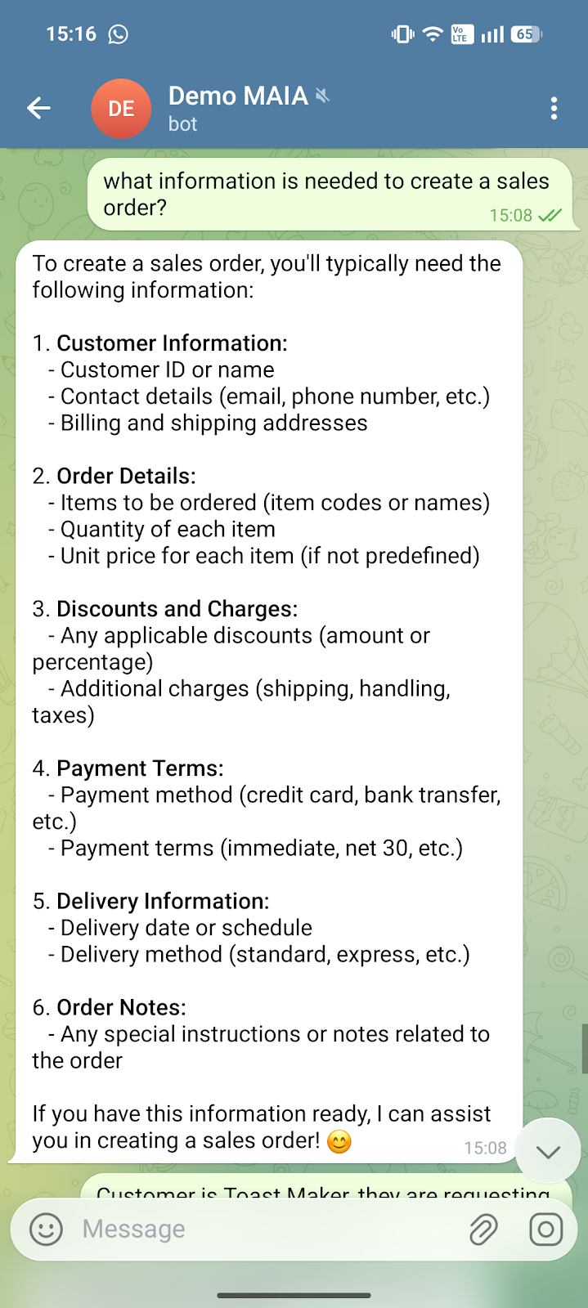 | 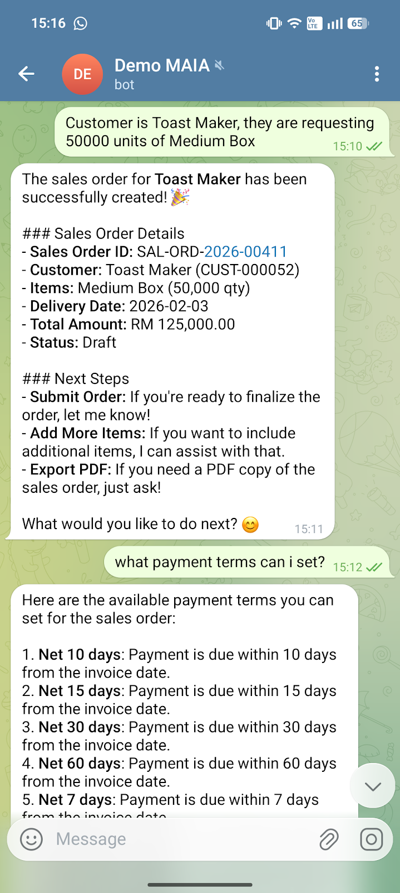 | 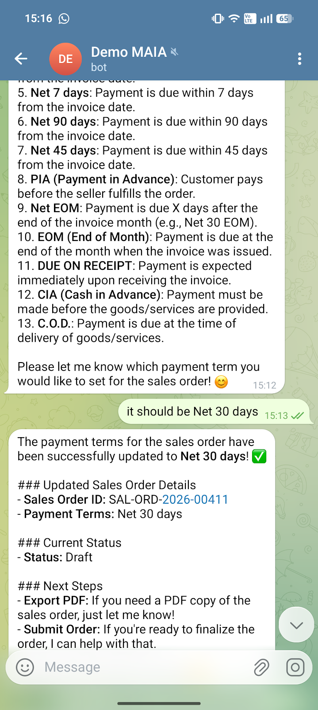

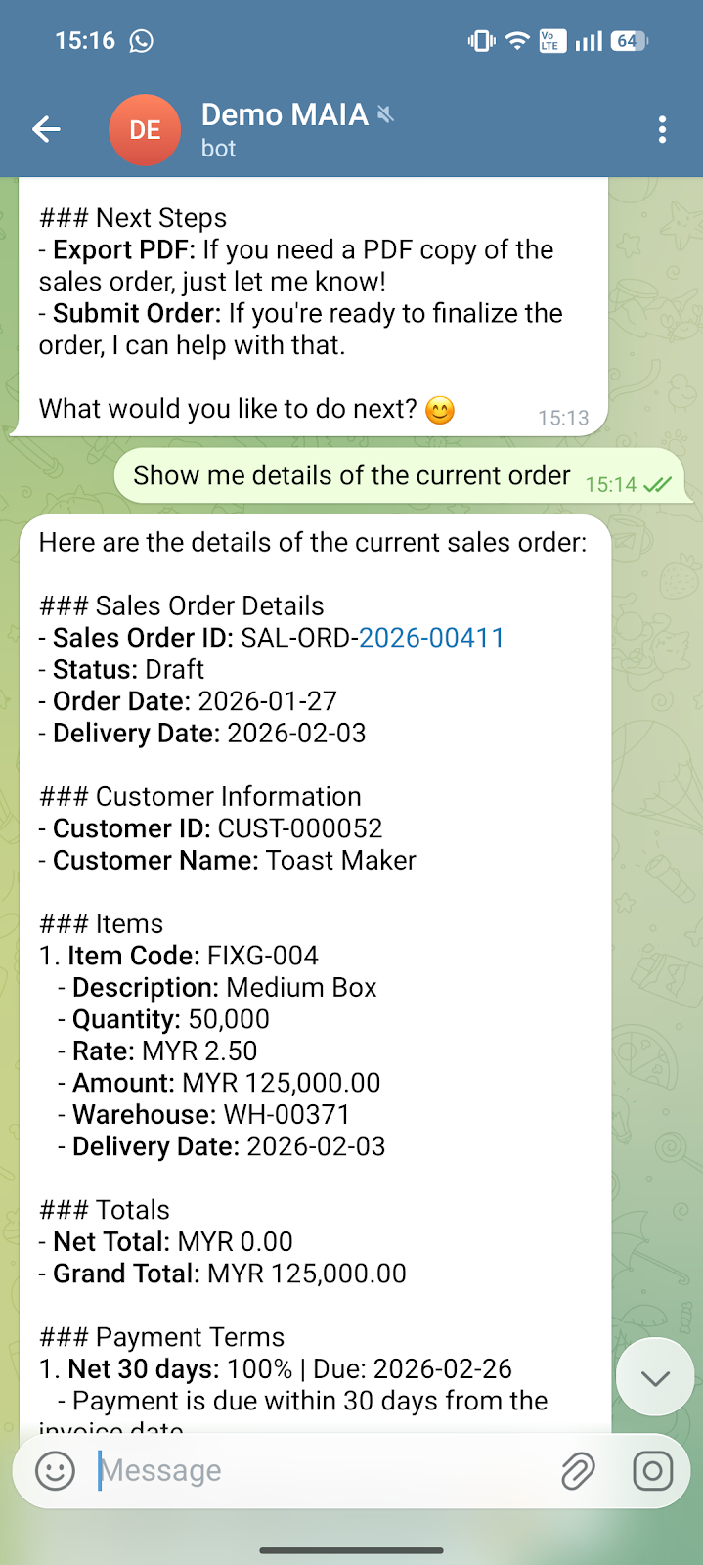 | 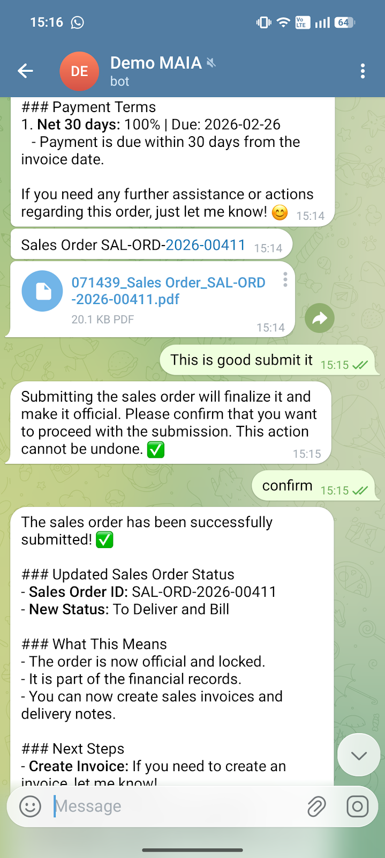 | 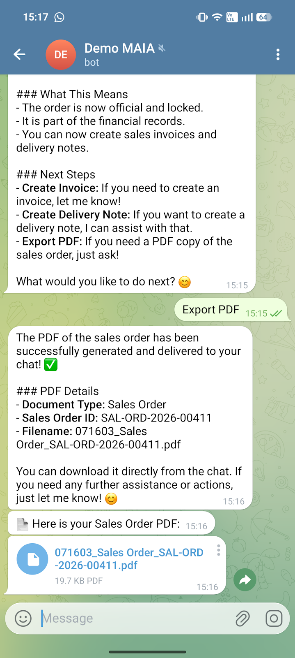
- Explains what’s needed to create a Sales Order
- MAIA lists the required fields (customer, items/qty, pricing, discounts, payment terms, delivery info, notes).
This helps non-ERP users give the right inputs without guessing.
- Creates the Sales Order in ERP from chat
- User gives: Customer = Toast Maker, 50,000 units of Medium Box
- MAIA generates a Sales Order (Draft) with order ID, delivery date, totals, etc.
- Shows available payment terms + updates the order
- User asks: “what payment terms can I set?”
- MAIA lists terms (Net 10/15/30/60/90, etc.)
- User chooses Net 30 days
- MAIA updates the Sales Order’s payment terms in ERP and confirms the change.
- Shows the current order details on request
- User asks: “Show me details of the current order”
- MAIA returns a structured summary: customer, items, rates, amounts, warehouse, delivery date, payment terms.
- Submits (finalises) the Sales Order with confirmation
- User says “submit it”
- MAIA warns it’s not reversible → user confirms
- MAIA submits the Sales Order and changes status (e.g., “To Deliver and Bill”), meaning it’s now official/locked.
- Exports and sends the Sales Order PDF
- User asks “Export PDF”
- MAIA generates the PDF and sends it directly to WhatsApp.

Benefits
- Faster order processing: create + finalise orders in minutes, without ERP back-and-forth.
- Less training needed: MAIA prompts for the right info and reduces “how to use ERP” dependency.
- Fewer errors & stronger controls: payment terms, quantities, and details are explicitly confirmed and logged.
- Clean audit trail: draft → submitted → document generated, with statuses and references.
- Instant documentation: official Sales Order PDF is produced and shareable immediately (sales/ops/finance/customer).

7) MAIA ERP (Backend System)
Scenario: Inventory Module
MAIA comes with an ERP level order management system that stores all the created sales orders.
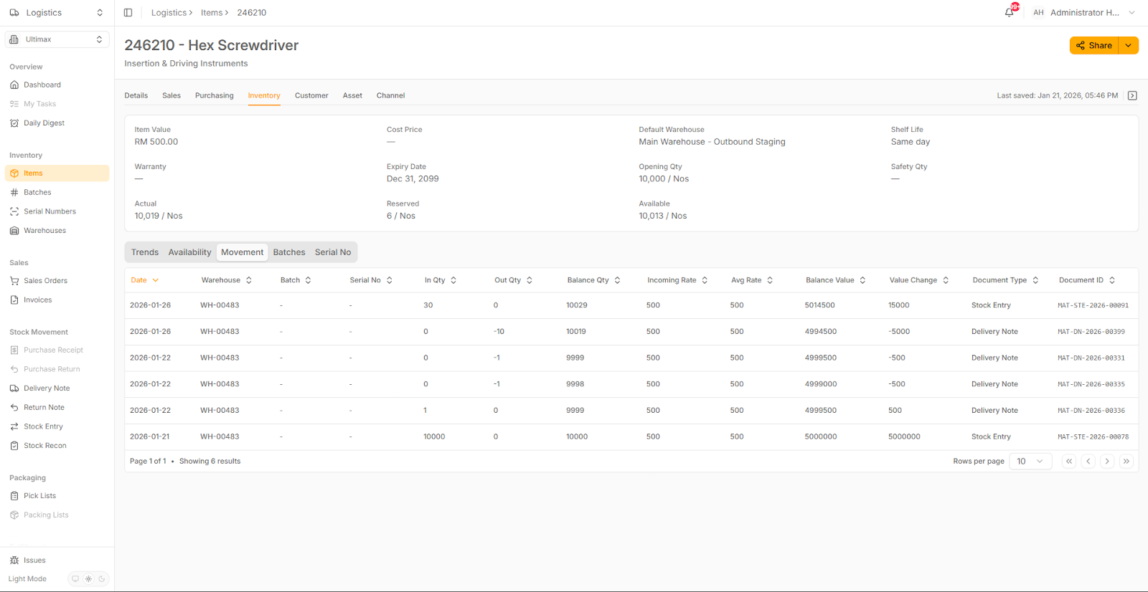
MAIA connects to your ERP’s inventory pages (item master + stock ledger) so your team can check real-time stock availability, reservations, and stock movements and MAIA can use that data to validate orders before they’re confirmed. On top of that, MAIA’s inventory module can display data and metrics such as the sales trend, availability of the SKU, etc.

Benefits
- Prevents overselling: Checks available vs reserved stock before confirming orders.
- Faster customer replies: Instant “do we have stock?” answers without opening ERP.
- Fewer internal back-and-forth: Sales, ops, and finance see the same stock truth.
- Easy stock traceability: Shows recent stock in/out with document references (DN/Stock Entry/etc.).
- Better decisions: Flags low stock, supports warehouse allocation, and enables smarter order automation.

8) MAIA ERP (Backend System)
Scenario: Inventory Module - Different customer different price
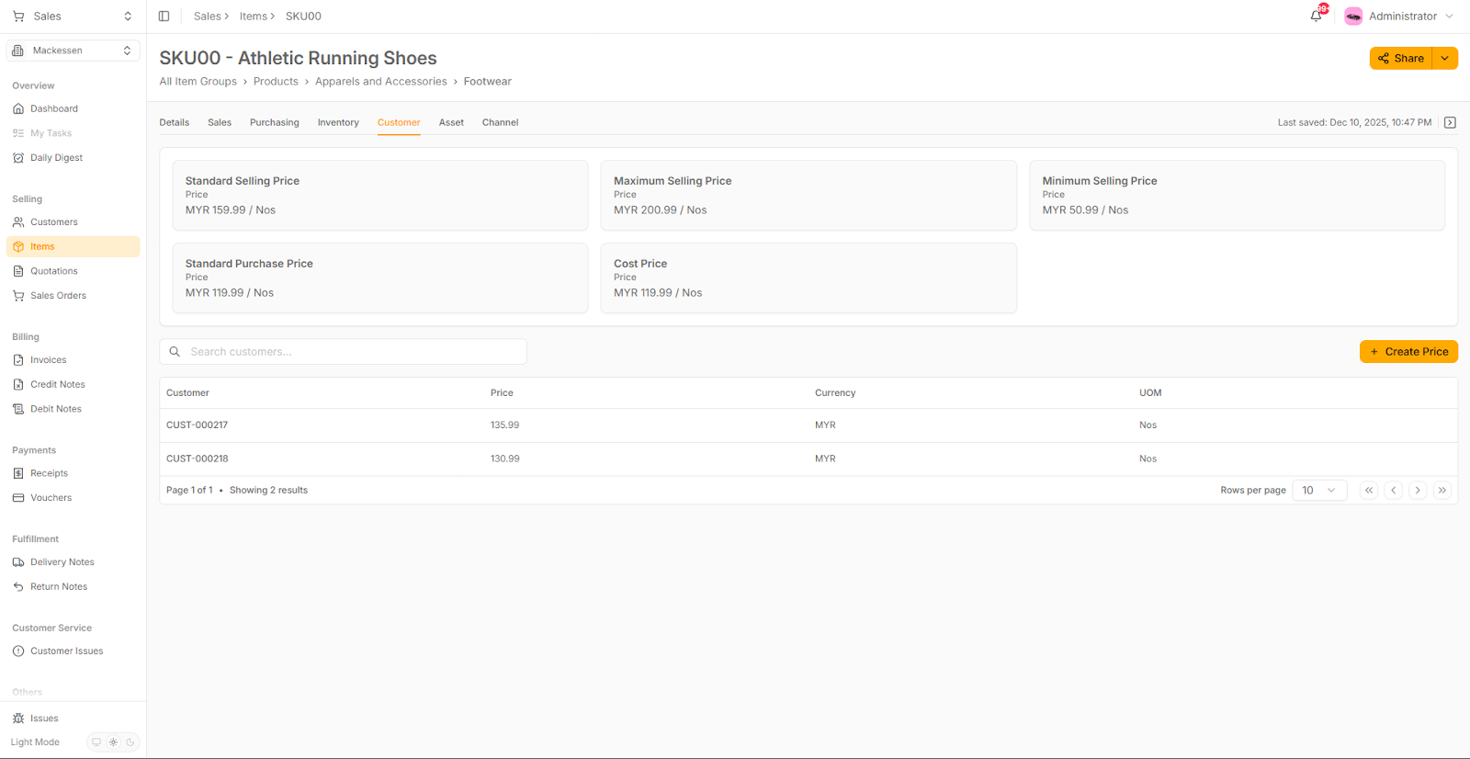
MAIA connects to your ERP’s item pricing setup so your team can instantly check what price to sell a SKU at, including different prices for different customers (customer price lists / special pricing), plus guardrails like minimum/maximum selling price.

Benefits
- Prevents wrong pricing: Avoids “quoted the wrong customer tier” mistakes and reduces disputes/credit notes.
- Faster quoting in WhatsApp: Sales can confirm the right price immediately without opening ERP.
- Supports customer-specific deals: MAIA can show “Customer A = RM X, Customer B = RM Y” for the same SKU.
- Better margin control: Minimum/maximum price checks help stop underpricing and protect profitability.
- Consistent execution across the team : Everyone follows the same pricing rules instead of relying on memory or old spreadsheets.

9) MAIA ERP (Backend System)
Scenario: Customer List - Multiple addresses for same customer
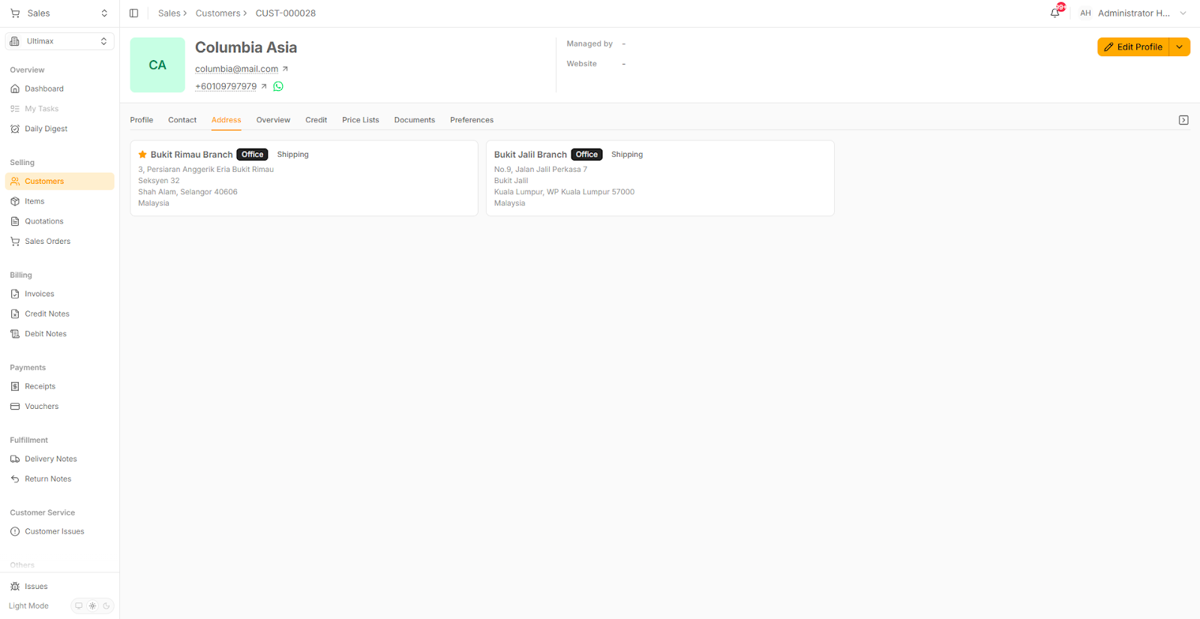
MAIA connects to your ERP customer profile, so your team can pull up a customer instantly in WhatsApp and see the key info needed to process orders correctly—contacts, delivery addresses/branches, credit terms/limits, assigned price list, and related documents/preferences.

Benefits
- Faster order taking: confirm the right customer + correct delivery address/branch without digging through ERP.
- Fewer delivery mistakes: reduces “sent to wrong branch / wrong address” issues by showing saved addresses clearly.
- Better credit control: ops/finance can quickly check credit status before confirming an order (prevents bad debt).
- Correct pricing automatically: MAIA can link the customer to their price list / special pricing, so the quote uses the right customer-specific price.
- Cleaner customer service: faster answers when customers ask “where’s my order / which address did you deliver to / what’s my account status?”.

